[The Real Scale of U.S. Defense Spending](http://reason.com/blog/2014/12/17/one-trillion-spent-on-war-in-afghanistan)

**[Veronique de Rugy](http://reason.com/people/veronique-de-rugy/all)**|Dec. 17, 2014 12:15 pm

Remember back in 2002 when President Bush allegedly canned his chief economic advisor, Larry Lindsey, for saying that the wars in Iraq and Afghanistan could cost more than $100 billion? Well, it turns out Bush was right to fire him because his estimates were way off! So far the cost of the wars to U.S. taxpayers is nearly $3 trillion—a figure that [could double](https://research.hks.harvard.edu/publications/workingpapers/citation.aspx?PubId=8956&type=WPN) in the future as the associated legacy costs (e.g., veteran healthcare benefits) mount.

And it can’t all be blamed on President Bush, because President Obama hasn’t been the tightwad peacenik that the military interventionists claim. According to [a story in yesterday’s Financial Times](http://www.ft.com/intl/cms/s/2/14be0e0c-8255-11e4-ace7-00144feabdc0.html#slide0), the war in Afghanistan has cost $1 trillion thus far and roughly 80 percent of that total was spent under the administration our Nobel Peace Prize winning president. From the article:

The Afghanistan war, the longest overseas conflict in American history, has cost the US taxpayer nearly $1tn and will require spending several hundred billion dollars more after it officially ends this month, according to Financial Times calculations and independent researchers.

Around 80 per cent of that spending on the Afghanistan conflict has taken place during the presidency of Barack Obama, who sharply increased the US military presence in the country after taking office in 2009. …The Afghan conflict has led to other increases in public spending that are significant but difficult to isolate. As well as the separate war funding it has received since 2001, the Pentagon’s “base” budget, which covers all its other costs, has also seen a dramatic increase, with the wars in Afghanistan and Iraq one of the main factors.

Given the political pressures surrounding the wars, military healthcare premiums paid by serving military members have been kept low, prompting a surge in healthcare spending by the Pentagon, while salaries have risen above inflation. Since 2001, the defense department’s base budget has increased by $1.3tn more than its own pre-9/11 forecasts

Speaking of unforeseen defense costs, it is worth noting that the actual taxpayer cost of maintaining America's global military presence and interventionist foreign policies is much higher than the Department of Defense's budget. The chart below [shows](http://mercatus.org/sites/default/files/C1-defense-spending-2013.jpg) the real scale of the government’s spending on defense-related activities.  The total for fiscal year 2013 is roughly $861 billion (not including interest which amounts to roughly $58 billion).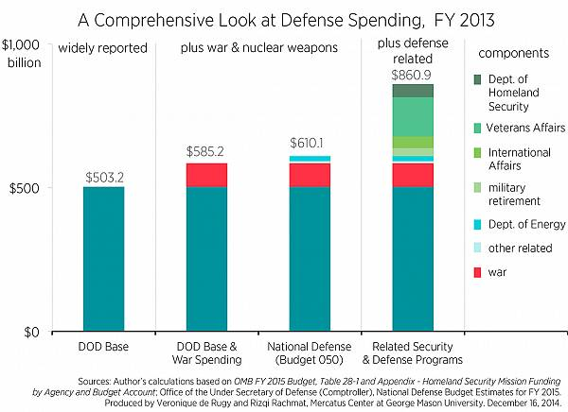

As we [document over at Mercatus](http://mercatus.org/publication/defense-funding-extends-beyond-pentagon-s-budget), while the majority of defense spending takes place in either the Pentagon budget or National Defense budget function, there is other funding related to national security and defense, which includes:

* $137 billion to Department of Veterans Affairs to care for wounded or retired military veterans.
* $46 billion to Department of Homeland Security for responding to terrorism and natural disasters.
* $41 billion to International Affairs for additional war funding, weapons training to foreign militaries, and foreign aid. There are nondefense-related items in this amount, such as operating U.S. embassies and consulates and normal diplomatic operations. However, these are all key components of the U.S. government’s national security apparatus.
* $27 billion for retirement costs for military pension benefits not included in the Pentagon’s budget.

The military interventionists on Capitol Hill having been agitating for an end to the 2011 Budget Control Act’s spending caps since the day they were accidentally implemented. With the Republican Party back in control of Congress, expect the drumbeat for more defense spending (and, gulp, more military interventions) to grow louder. When they do, it would be helpful if the press *pressed* the Pentagon blank-check crowd on how much taxpayers are *really* paying to keep Uncle Sam’s nose in everyone’s business.

Veronique de Rugy, Ph.D., is a senior research fellow at the **[Mercatus Center](http://www.mercatus.org/)** at George Mason University and a monthly columnist for the print edition of *Reason*.

[**Media Contact**](http://reason.com/flatpage/item/media-contact) [**Reprint Requests**](http://reason.com/flatpage/item/reprint-requests)